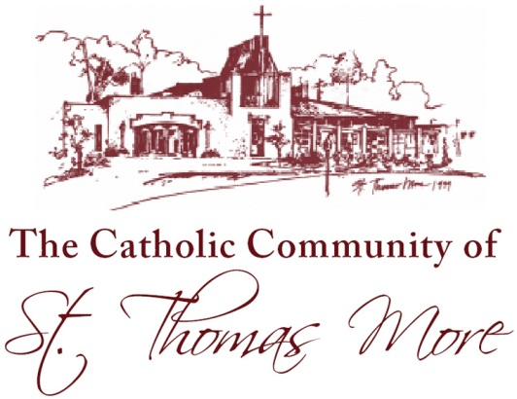

940 Carmichael Street, Chapel Hill, NC 27514-4203

(Phone) 919.942.1040 (Fax) 919.942.6193 (Web) www.stmchapelhill.org

Dear Parent:

We are pleased to welcome you to the Nursery Ministry of St. Thomas More Church!

In the Nursery we consider every child a blessing from the Lord, and we desire to serve the needs of you and your child as we would serve Christ. We attempt to provide a safe and entertaining environment so that each child will feel happy and loved. Our goal is for you to be comfortable in the knowledge that your young child is nearby, safe and cared for, so that you and your family may participate more fully in the Mass. We hope you will enjoy being a part of our mission to meet the spiritual and fellowship needs of families with young children here at St. Thomas More.

We hope the information found here will convey our commitment to you and your child. Please take the time to carefully read our policies and procedures before submitting your membership forms. We welcome your questions and comments.

Thank you for your trust.

In His Service,

Sarah and Amber

Sarah McGill and Amber Jarvis  
Nursery Ministry Coordinators  
  
Sarah: 919-360-8593; Amber: 919-407-0586   
Email: [nurserycoordinators@yahoo.com](mailto:nurserycoordinators@yahoo.com)